Title of the Article

Name of the author
Abstract
Text of the abstract.
Recommended extent is 200 words. Abstract is not divided into paragraphs and does not include citations. It should include objective, methods, results, and conclusion.
Keywords
3 – 7 keywords.

I. Introduction
Text of the introduction.

II. Main text
The extent of the entire paper should not exceed 10 pages. Please, use footnotes for citations, e.g. , or cite the literature directly in the text, e.g. “…as mentioned by Baláž (2008)”.
All equations should be numbered using parentheses, e.g. (1). Tables and figures should have the following format in greyscale only. Numbered tables and figures send in the attachment, please.
Please, do not use any spacing between paragraphs, tabulators, etc. that are not pre-defined.
Table 1: Name of table

 | 2013 | 2014 | 2015 | 2016
Príspevok na bývanie | 42,7 | 44,6 | 48,5 | 48,6
Source:
Figure 1: Name of figure
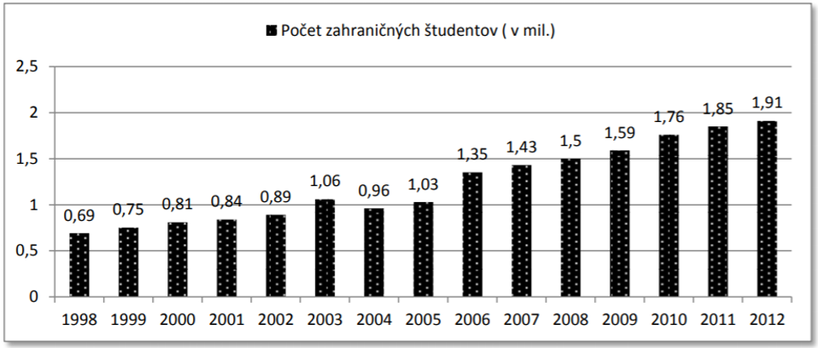
Source:

III. Next chapter
All chapters, including the conclusion, should be numbered as shown above using Roman numerals.

IV. Conclusion
Text of the conclusion.
Acknowledgements
Text of the acknowledgements (if any).
References
Please, use the following patterns for references (APA Citation Style). All mentioned references must be cited in the text/footnotes and vice versa.
Journal Article
Author (Year). Article Title. Journal Title, vol.(no.), pages.
e.g. Williams, A. M., Baláž, V., & Wallace, C. (2004). International labour mobility and uneven regional development in Europe: human capital, knowledge and entrepreneurship. European Urban and Regional Studies, 11(1), 27-46.
Book
Author (Year). Book Title (Edition). City of publication: Publisher.
e.g. Williams, A., & Baláž, V. (2014). International migration and knowledge. Routledge.

Chapter in a Book
Author (Year). Chapter Title. In Editor (ed.). Book Title (Edition). City of Publication: Publisher.
e.g. Holmes, S. (1988). Precommitment and the Paradox of Democracy. In Elster, R.; Slagstad, R. (eds.). Constitutionalism and Democracy (1st ed). Cambridge: Cambridge University Press.

Web Site
Publisher/Company. (Year accessed). Web Site Title. Retrieved “date” from “URL”.
e.g. Eurostat. (2016). Migration and migrant population statistics, Immigration by five year age group, sex and citizenship. Retrieved from http://ec.europa.eu/eurostat/data/database (25.1.2016).

Appendix
All appendices should be numbered using numbers, e.g. Appendix 1.

The affiliation (including full address) and e-mail of the author(s), e.g. Centre of Social and Psychological Sciences, SAS, Šancová 56, 811 05 Bratislava, Slovakia. E-mail of author.
Baláž (2008).

